EXPERIMENT 7
1. CREATE TABLE bank_017(bankname VARCHAR(50),headoffice VARCHAR(50),branch VARCHAR(50),branchcode INT);

insert into BANK_017 values('SBI','Mumbai','Kottayam',101);
commit;
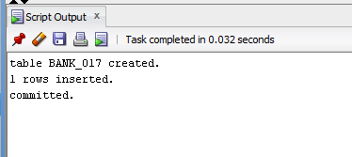
2. insert into BANK_017 values('HDFC','Mumbai','Pala',102);
savepoint Q1;
insert into BANK_017 values('ICICI','Delhi','Kochi',103);
savepoint q2;
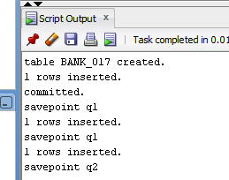

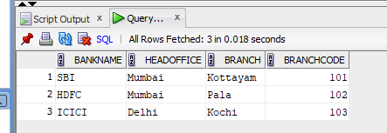
rollback to q1;
.